STEPPERS TO RUN BTS

- DOWNLOAD MOZILLA FIREFOX BROWSER FROM THE INTERNET

- INSTALL IT

- OPEN THE BROWSER

- TYPE ABOUT:CONFIG IN THE URL
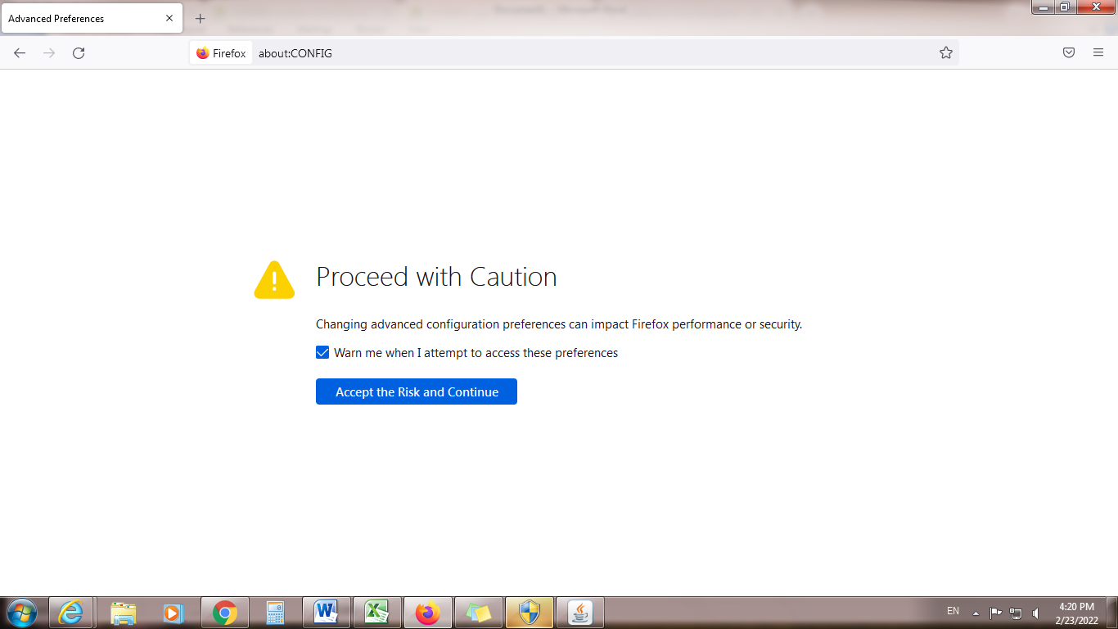

5

4
- CLICK ACCEPT RISK AND CONTINUE

Continued to next page
- TYPE TLS IN SEARCH REFERENCE NAME
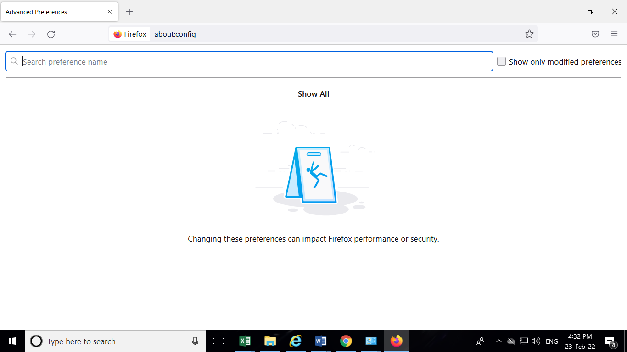

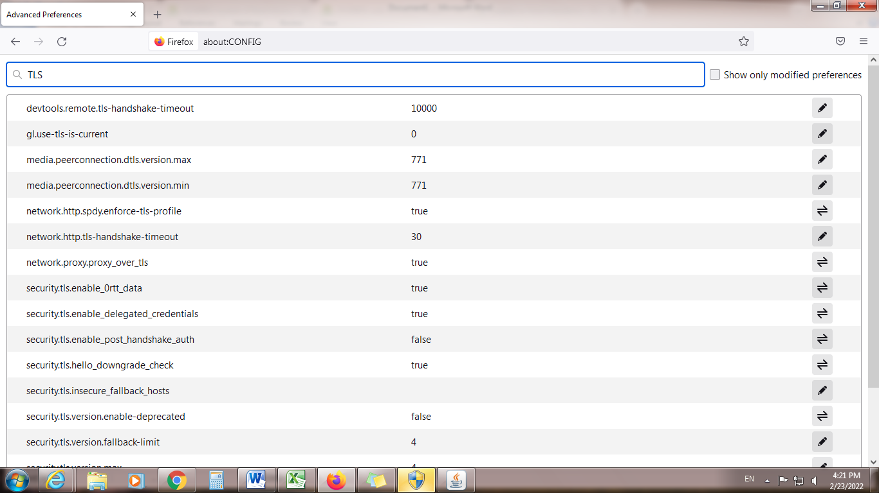
6

Continued to next page

- SCROLL DOWN TO security.tls.version.min
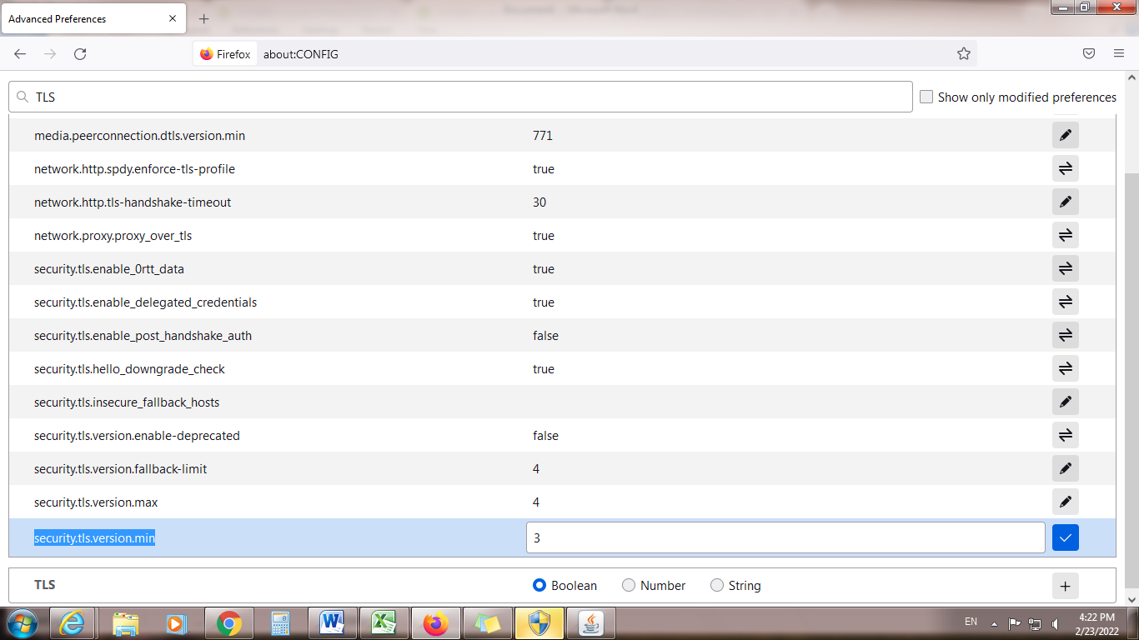
7

- EDIT THE VALUE FROM 3 TO 1

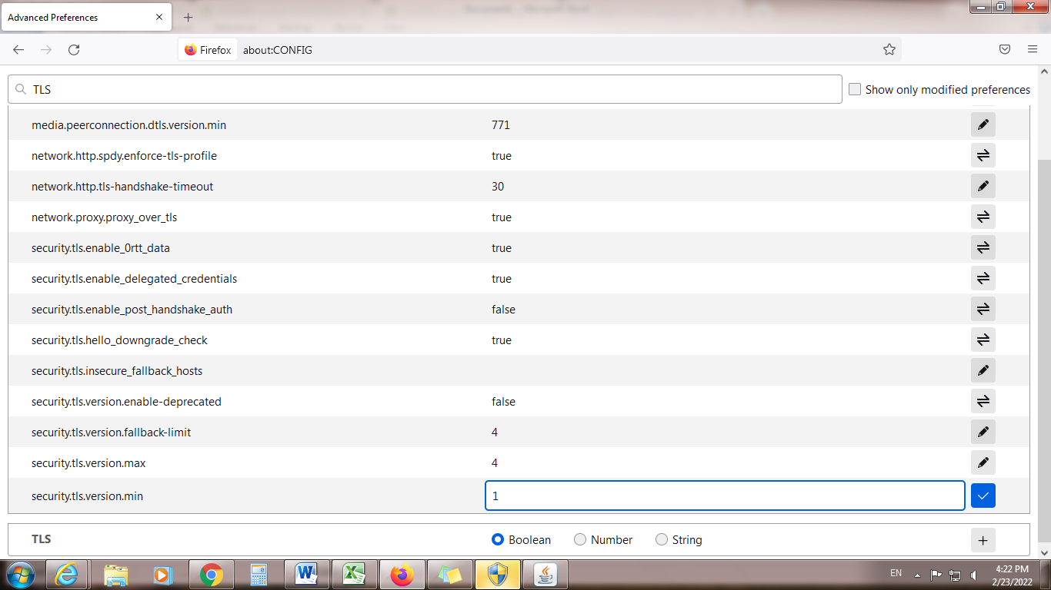
8
- CLICK TICK
- RESTART BROWSER AND FOR CONTINUITING WITH BTS PLEASE SELECT “ACCEPT RISK AND CONTINUE”

